R. Reports Menu: F. First American Export

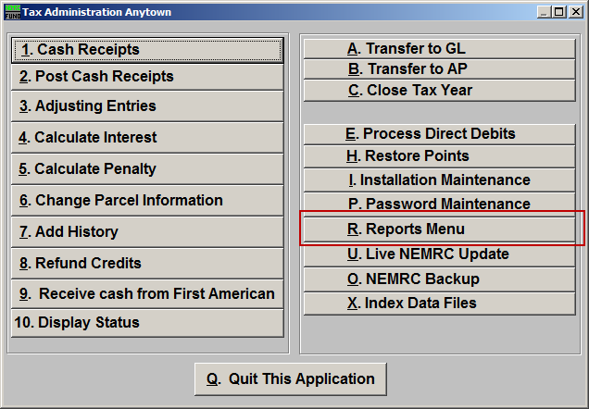
Click on “R. Reports Menu” from the Main Menu and the following window will appear:

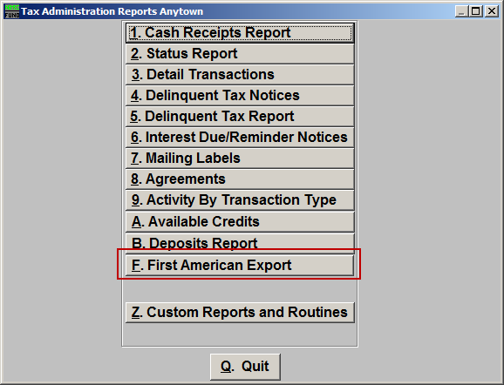
Click on “F. First American Export” from the Reports Menu and the following window will appear:
First American Export

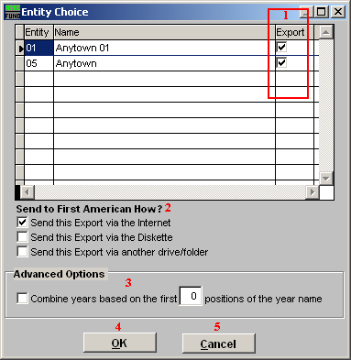
- Export: Check the box in this column to have the entity data included in the export.

- Send to First American How?: Check to choose how selected items will be exported.

- Advanced Options: If your data for a single tax year is stored in multiple records in the tax files then the company would like them combined to one record for processing payments. The tax year naming convention you use should facilitate that process with this option. The following example of a town tax bill loaded as year ‘2008T’ and an Education tax bill loaded as ‘2008S’ would result in the check box to combine being selected and the first 4 positions of the year name to be used for totaling purposes to report. Contact support if you need assistance with this option.

- OK: Click “OK” to save changes and return to the previous screen.

- Cancel: Click “Cancel” to cancel and return to the previous screen.

